

# Placement Empowerment Program

***Cloud Computing and DevOps Centre***

Automate File Copying with a Script

Create a script to copy files from one folder to another automatically.

Name : SREEVATSAN V P Department : AIML

# Introduction

Automating repetitive tasks like file copying helps save time, minimize errors, and boost efficiency in tasks such as managing backups, organizing files, or syncing data across directories. This PoC script will showcase a straightforward yet effective method to automatically copy files from one folder to another

# Overview

The script automates the process of copying files from a source folder to a destination folder, ensuring efficient and reliable file transfer while preserving their integrity. It can be customized to meet specific requirements, such as copying files based on type, modification date, or size. Depending on the operating environment, the script can be written using programming languages like Python, Shell scripting, or PowerShell.

# Objectives

The key objectives of this automation task are:

**Simplify File Management**: Minimize manual effort in moving or copying files between folders.

**Improve Efficiency**: Automate the process to save time and enhance productivity.

**Ensure Data Integrity**: Ensure accurate file copying with no corruption or data loss.

**Customizable Workflow**: Provide flexibility to adapt to specific requirements, such as filtering files by type or date.

# Importance

**Time-Saving**: Automating the process removes the need for manual intervention, saving valuable time.

**Error Reduction**: Minimizes human errors, such as overlooking important files or accidentally overwriting them.

**Improved Organization**: Ensures consistent structure and organization for file storage and backups.

**Versatility**: This automation is beneficial for IT professionals, businesses, and individuals handling frequent file transfers or backups.

**Scalability and Reusability**: Once created, the script can be reused and scaled to handle more complex or larger tasks.

# Step-by-Step Overview

## Step 1

Create two folders named Source and Destination

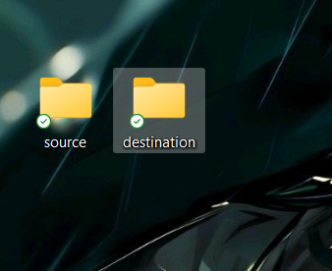

## Step 2

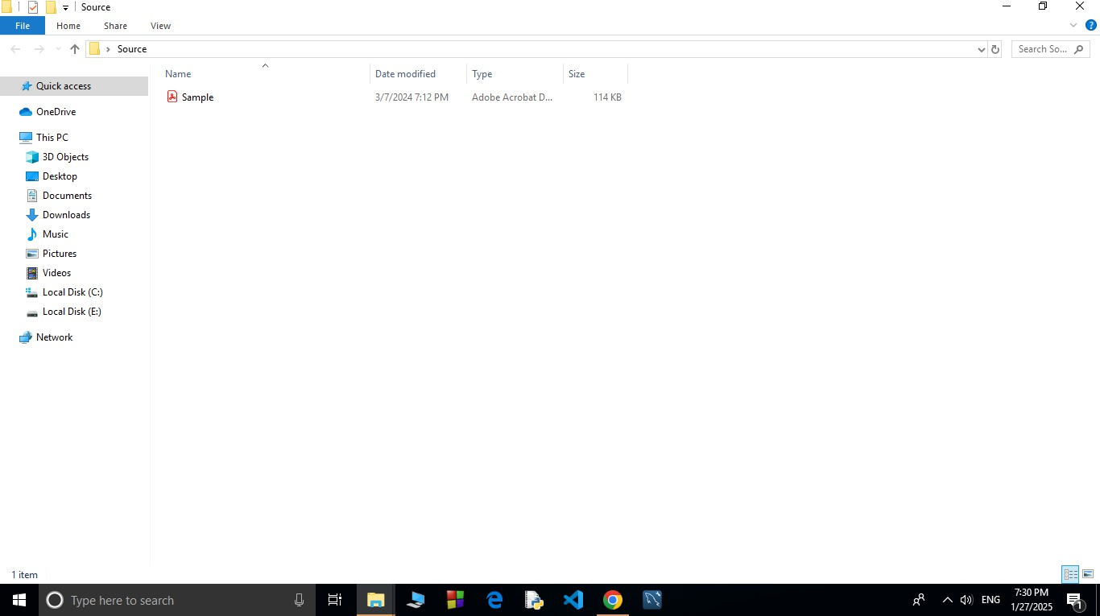Store some files inside it to automate it

## Step 3

Open the note pad and type the code and make sure that in set SOURCE give your Source folder address and in set DESTINATION give your Destination Folder address

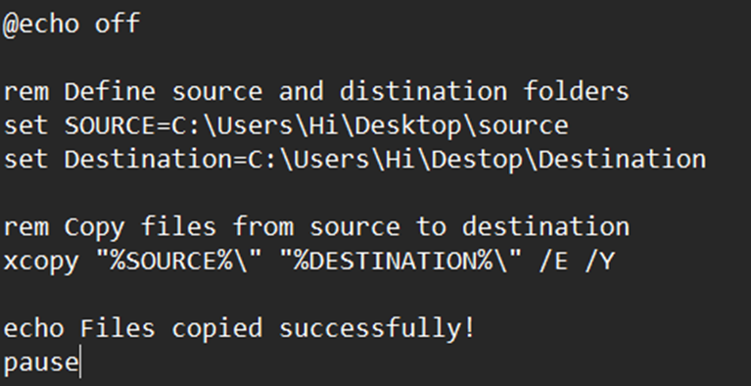

## Step 4

Then save the file in desktop with .bat extension (eg : index.bat) so the file looks like this

## Step 5

Press **Win + R** on your keyboard.

A small "Run" dialog box will pop up.

Type **taskschd.msc** (without quotes) in the Run box.

Press Enter or click OK.This will open the Task Scheduler window.

## Step 6

In the Task Scheduler window, look to the right-hand side for a button called **"**Create Basic Task**"**.

Click it.

A wizard will open to guide you through the setup.

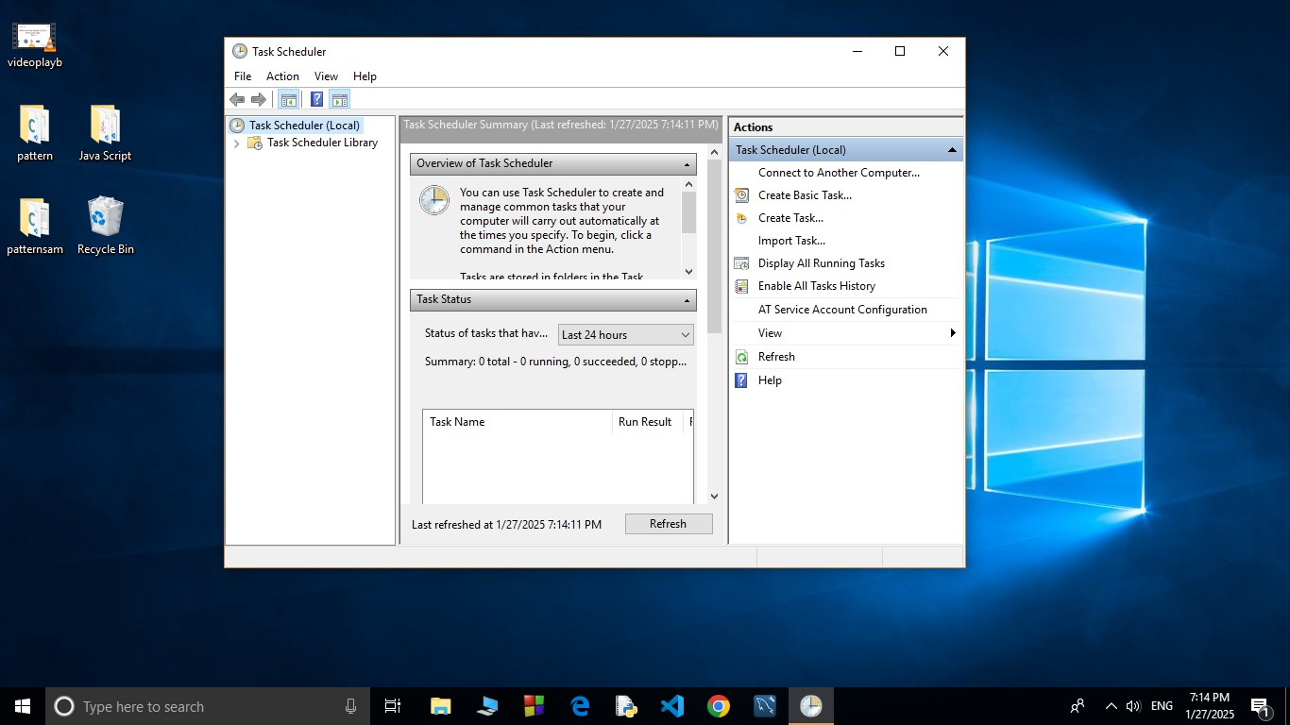

## A screenshot of a computer Description automatically generated Step 7

1. Enter a Name for the Task:

For example: "Automate File Copying".(This can be anything that helps you remember what the task does.)

Optionally, you can add a description like "Copies files from folder A to folder B".

1. Click Next to continue.

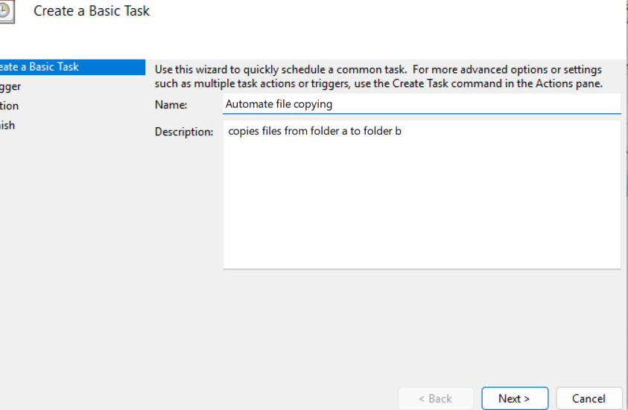

## Step 8

Choose a Schedule:

You will see options like: Daily (runs every day).

Weekly (runs once a week).

One time (runs only once at a specific time).

Choose what works for you (e.g., Daily) and click Next.

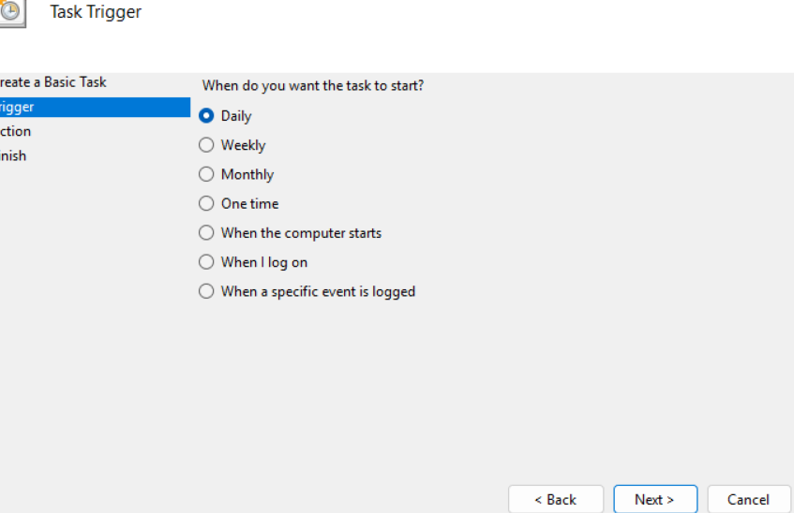

## Step 9

Set the Time and Frequency:

If you chose Daily, specify:

The start date (it defaults to today).

The time (e.g., 10:00 AM). Click Next to move on.

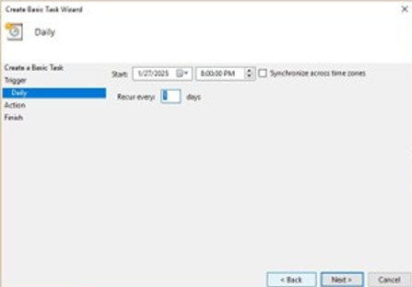

## Step 10

Set the Action

Now, we tell Task Scheduler what to do when it runs.

Select "Start a Program":

On the "Action" screen, select the option **"**Start a Program**"** and click Next.

## Step 11

Point to the Program or Script:

In the Program/script field, click **Browse** and navigate to the location of your .bat file.

Example: If your script is named index.bat and saved on the desktop, navigate to that file and select it.

Click Next.

## Step 12

Review and Finish

Click **Finish** to save and schedule the task.

In Task Scheduler, go to the **Task Scheduler Library** (on the left-hand side).

Find your task (it should have the name you gave it, e.g., "Automate File Copying").

Right-click the task and select **Run**.

This will manually trigger the task immediately.

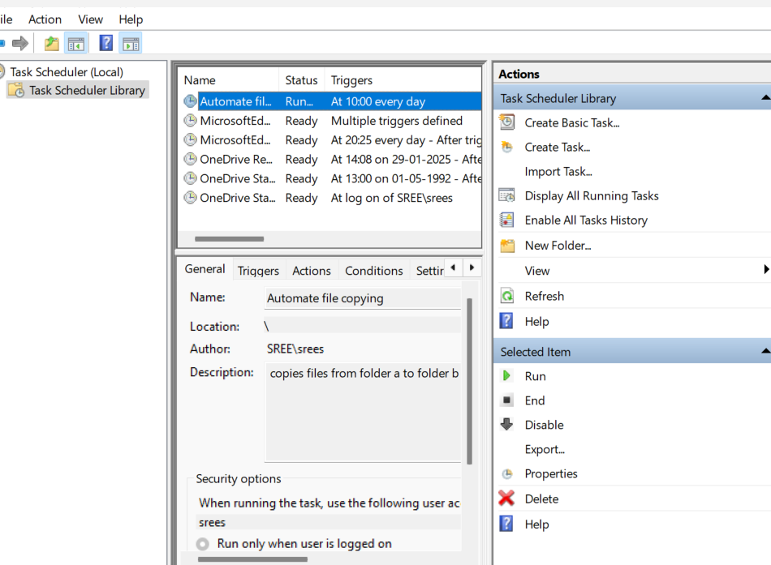

## Step 14

If your task was set up to copy files, go to the destination folder and confirm that the files have been copied.

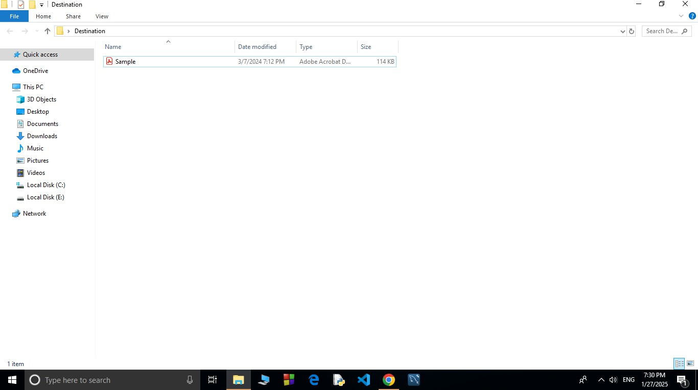

# Outcome

By completing this Proof of Concept (PoC) for automating tasks using Task Scheduler, you will:

1. Set up an automated task that runs on a schedule or manually triggers.
2. Execute a batch script to automate the copying of files from a source folder to a destination folder.
3. Learn to use Task Scheduler to streamline repetitive tasks and improve workflow efficiency.
4. Understand how to configure task triggers, actions, and conditions for optimal automation.
5. Gain hands-on experience with automation, saving time and ensuring consistent task execution.